# Terrain Identification from Time Series Data

### **Background**

### Humans naturally develop walking capability that is energy efficient, stable, environment adaptive, and robust. Lower limb amputations, unfortunately, disrupt this ability; individuals with lower limb amputations usually depend on prosthetic devices to restore the basic walking function. Lower-limb robotic prosthetics can benefit from context awareness to provide enhanced comfort and safety to the amputee. In this work, we aim to develop a terrain identification system based on inertial measurement units IMU streams collected from the lower limb. The system for a prosthetic leg uses visual and inertial sensors though, but we are willing to observe if terrain identification without the visual data is viable. With such information, the control of a robotized prosthetic leg can be adapted to changes in its surrounding.

### **[Data Set]** Lower Limb IMU

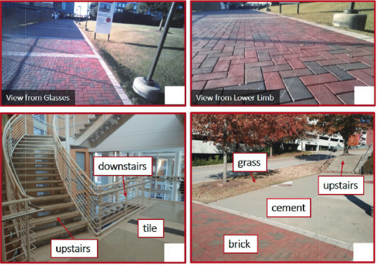

**Note: Not all terrains in the above images have been annotated and the annotations are done by hand for demonstration purposes.**

Data will consist of at several sessions from 6 different subjects including IMU data from a sensor on the leg of a participant, and the labels come from annotations of terrain type from a synchronized data stream. We only make use of the IMU data for this project. This work is inspired by this research project: <https://research.ece.ncsu.edu/aros/paper-tase2020-lowerlimb/>

### **[Task]** Types of terrains

This is a classification task to find different terrains from time series data. The idea is to train a neural network using given data to classify which terrain an unknown data represents. We will use F1 score as the evaluation metric for this project.